March Madness tournament winner prediction model
prepared by: Devin guigley
Analysis conducted: 3/17/26
Report generated: 4/22/26

Table of contents
Executive Summary…………………………………………………………………………………………………….3
Introduction……………………………………………………………………………………………………………4
Methodology…………………………………………………………………………………………………………...5
Findings………………………………………………………………………………………………………………..6
Reflection……………………………………………………………………………………………………………...9
Appendix……………………………………………………………………………………………………………...10

executive summary
This analysis was conducted to predict which team would win the 2026 NCAA March Madness tournament. This analysis looked into some key statistics from previous tournament winners to identify shared traits and then analyzed the 2026 NCAA Division I to find teams that shared those same characteristics. From this analysis, the following statistics were discovered to be common traits among tournament winner teams:
- Top 9 offensive efficiency rating (ORTG)
- Top 22 defensive efficiency rating (DRTG)
- Season three-point percentage over 35.5% (3PT%)
The analysis also showed that tournament winners since 2002 have in general been better on offense than on defense (when comparing how they ranked in offensive and defensive efficiency). Additionally, the last 10 tournament winners have all had a higher rated offense compared to defense.
Looking over the 2026 tournament field and comparing teams to the stats listed above, the analysis concluded that there were two teams that met the three listed stats above:
- Arizona Wildcats: #5 ORTG, #3 DRTG, 36.0 3PT%
- Michigan Wolverines: #8 ORTG, #1 DRTG, 36.2 3PT%
Looking at the numbers from the previous 10 winners, only one team had an ORTG ranked lower than 8th, (2017 North Carolina, 9th in ORTG). Additionally, the DRTG’s of the winning tournament teams since 2014 have ranged from 4th to 22nd. The last team to win the NCAA tournament with the top ranked DRTG was Louisville (2013).
The two teams above meet most criteria of the last 10 tournament winners. While both defenses are higher rated than the offenses, no other teams in the tournament meet the ORTG > DRTG trend while also meeting the other identified trends. Therefore, realizing that historically ORTG has a higher correlation to winners than DRTG, this analysis concluded that the winner of the 2026 NCAA tournament would be the Arizona Wildcats.

introduction
The NCAA Men’s Basketball Tournament (known as “March Madness”) is one of the most popular sporting events of the year in the United States. The 2026 tournament had an average of 10.3 Million viewers throughout the tournament. For reference, the opening weekend of the NBA playoffs has averaged 4.4 Million viewers through the first weekend of the first round. Additionally, 26.6 Million people filled out brackets for the March Madness tournament in 2026 on ESPN, and an estimated $3.3 Billion was wagered by gamblers during the tournament.
While predicting the outcome of the tournament is near impossible (there has never been a perfect bracket in the history of brackets), predicting the winner is a much more accomplishable task. For those who are interested in picking a winning bracket (or in my case, bragging rights over my wife’s family), picking the winner will reward the most points for your bracket, and in most cases is the make-or-break for winning your bracket pool.
The goal of this analysis was to identify any trends among tournament winners since 2002 and use those trends to identify which teams in the 2026 field share those same characteristics. 2002 was the cutoff because the stats on Kenpom.com only go back to 2002, which was used for approximately half the stats (including the ORTG and DRTG stats). This analysis was done only to predict the winner of the NCAA tournament; Future iterations of this analysis should focus on expanding to predicting Final Four teams and possibly building a predictive model for the entire field.

Methodology
The data for this analysis comes from two main sources:
- Kenpom.com (Net Ratings, Offensive Ratings, Defensive Ratings)
- SportsReference.com (3 point %, Pace)
Additionally, some additional insights were gained from Ryan Hammer and his Trapezoid of Excellence (X: @ryanhammer09), which compares net rating vs. pace. This scatter plot compares how efficient teams are on the offensive and defensive ends against how many possessions they average per 40 minutes.
The primary tools used for this analysis were Python and Excel. Python was used for web scraping the data from Sportsreference.com (and unsuccessfully from Kenpom). Using the Python BeautifulSoup library, Sportsreference.com was scraped and parsed into a CSV file, which was then read back into the Python code. BeautifulSoup was also used to clean some of the extra headers within the table and remove unused columns. The Kenpom stats were simply copied into an excel file, then opened in Python. Python was then used to format the team names between the two data sources to ensure they matched, and then used to join the dataframes together using an Outer Join.
After combining the dataframes together, the data was exported to Excel for visualization and analysis. Here, two datasets were created; one from the Python code which contained all the information about the current 2026 NCAA DI teams, and another which contained the historical information from the tournament winning teams going back to 2002. The historical winners data was compiled from Kenpom and SportsReference, copied and pasted into an excel sheet. Historical data that was compared was based on historical trends found from online searches:
- Since 1989, 36 of 37 tournament winners were ranked as a 4-seed or higher in the tournament (exception: 2014 UCONN, 7 seed)
- Since 2002, each winner was in the top 25 in ORTG before the start of the tournament (exception: 2014 UCONN, 58th before tournament, 39th after tournament)
- Since 2002, each winner was in the top 40 in DRTG before the start of the tournament (exception: 2021 Baylor, 44th before tournament, 22nd after tournament)
- Since 1989, each tournament winner has shot higher than 33% from 3-point.
From this info, plus the net-rating vs. pace numbers from Ryan Hammer, the current season stats from the field could be analyzed. Rankings were added to ORTG and DRTG numbers to provide a better understanding of how a teams ORTG ranked against the rest of DI. Teams were then filtered depending if they made the 68 team field, followed by filtering stats based on our analysis of the historical winners.

findings
To begin, the historical dataset was analyzed to determine what exactly defines a championship winning team. The historical champion data was analyzed using Excel to identify trends between winners. All analysis materials and code can be found using the GitHub link in the appendix. A screenshot of the data is below:
Figure 1: Historical Stats
A quick look over the stats leads to a few observations that are easily identifiable from the above table:
- Since 2002, only three teams have had an ORTG outside of the top 10.
- 16 of the previous 23 champs have had a top 5 ORTG (69.57%)
- No team had a DRTG outside of the top 25
These observations set the foundation to begin looking for a contender to pick. However, the stats from the previous 10 winners show one more trend: None of the previous 10 winners had an ORTG lower than 9th. However, the DRTG ranks ranged between 5th and 22nd. This leads us to believe that offense has a greater impact on championships than defense. Some more in-depth analysis reveals some more findings:
- 17 of the last 23 champs had an ORTG rank higher than DRTG rank (73.91%)
- The last 10 champs have had an ORTG rank higher than DRTG rank
- Since 2002, only 3 winners had a 3PT% under 35%
- The last 10 champs had a 3PT% over 35.5%
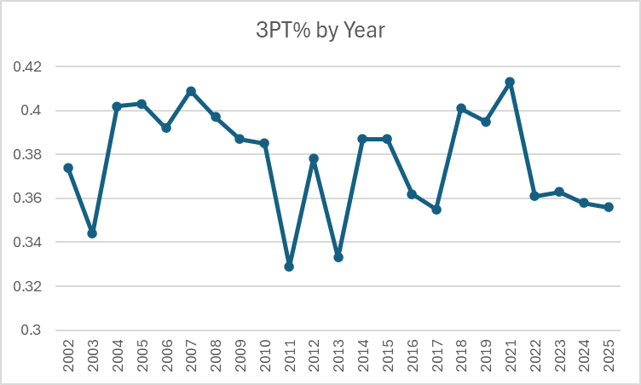
Figure 2: 3PT% by Year, NCAA Tournament Champs
From the information derived from above, the following conclusions were drawn which could be applied to the current field of teams:
- They should have a top 9 ORTG
- They should have a top 25 DRTG
- They should shoot better than 35.5% from 3PT%
Applying that logic to the current field, we find that 35 teams in the current tournament field shoot over 35.5%. Next, we find that the top nine ORTG teams are:
- Purdue
- Illinois
- Alabama
- Duke
- Arizona
- Arkansas
- Vanderbilt
- Michigan
- Brigham Young
Using those two filters on our dataset, we can narrow down the list of potential champs to five: Purdue, Alabama, Arizona, Arkansas, Michigan. Of those 5 teams, we can turn to the DRTG which whittles down our list of candidates to two teams:
Figure 3: Filtered Tournament Teams Result
We can also use Hammer’s “Trapezoid of Excellence” as a reference point for our teams. While there isn’t enough data to use it as a determining factor (only two seasons of data I could find online), it can be used as a check to make sure our analysis is on the right track. The figure below shows that both Arizona and Michigan fall within the trapezoid, with a net rating between 20-40 and a pace of 63-75 possessions per 40 minutes.
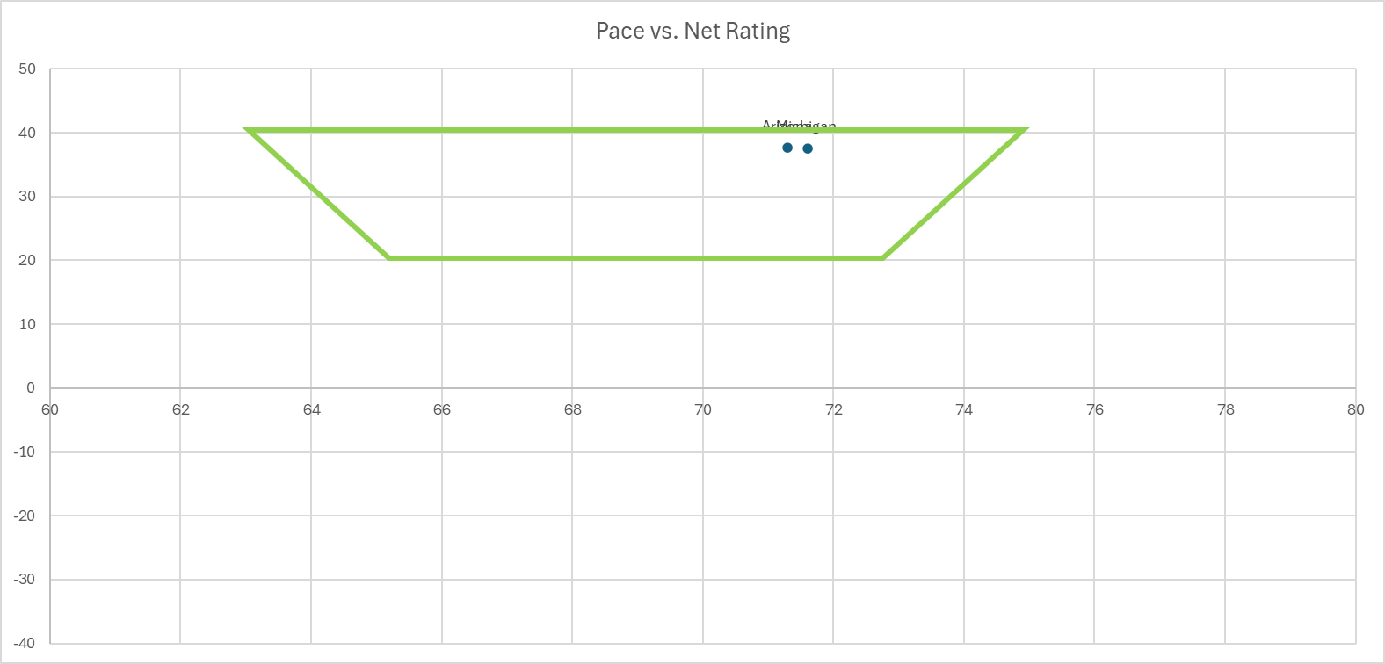
Figure 4: The "Trapezoid of Excellence"
Using the data found from the historical champions, it was determined that ORTG has a larger correlation on determining championship winners than DRTG. Following that logic, Arizona was given the slight edge as the selection as favorite for the championship over Michigan.

reflection
Following up the analysis above, the Michigan Wolverines finished as the champs of the tournament. The UCONN Huskies were the runners up, and the other two Final Four teams were the Arizona Wildcats and Illinois Fighting Illini. While the analysis was overall successful and did identify Michigan as one of the two possible champions, some further analysis could have provided more insight into picking Michigan over Arizona. Some items are listed below to take into consideration for future iterations of this analysis.
- Expansion of statistics: While the stats used were useful and had historical backing based on background research, many stats were left out which may have been able to provide more insight such as Free Throw %, Field Goal %, Rebound %, and Turnover %. These stats are routinely discussed during the tournament as factors and should be included in the future.
- Normalization & Correlation: Future analysis should normalize the statistics and use correlation functions to find which statistics carry more weight for determining championship winners. Python has libraries to conduct this kind of analysis and should be used in the future.
- Predictive modeling: Using Pythons predictive modeling libraries could be used to build predictive models. This would allow us to train models using data from championship teams to then predict potential future winners.

appendix
Data & Code:
https://github.com/Devin6295/March-Madness-Tournament-Winner-Predictor
References:
- https://apnews.com/article/march-madness-tv-ratings-dd0cd0dc9bb64d9d8291b2f7ad4fa394
- https://www.espn.com/nba/story/_/id/44800920/adam-silver-calls-nba-ratings-opening-weekend-playoffs-fantastic
- https://espnpressroom.com/us/press-releases/2026/03/26-6-million-brackets-espn-tournament-challenge-sets-new-record-for-fourth-consecutive-year/
- https://www.americangaming.org/americans-to-legally-wager-3-3-billion-on-march-madness-nearly-half-of-digital-sports-betting-ads-now-come-from-prediction-market-platforms/

